Notebook 6: Express.js POST Requests

You can use POST requests to submit data from forms.

# Requirements

* Previous tutorials
* Files from previous tutorials
* A code editor
* A web browser

# Parsing URL-encoded request bodies

1. Open your JS file in your code editor.
2. Toward the start of your code (but after “app” is defined), add this:

### app.use(express.urlencoded({extended: true}));

This allows you to get data from POST requests.

# Creating a POST endpoint

1. Add the following code at the end. This is the basic syntax for a POST endpoint in Express.js.

### app.post('/formdata', (req, res) => {

### 

### });

# Reading a POST request’s body

1. Inside the empty function, add this:

### res.render('index', {

### bodytext: `${req.body.string}<br>${req.body.string2}`

### });

Use req.body.[[element’s name]] to get data submitted from the form.

Now, when you submit the form, you will see the text you input into each box.

## Example

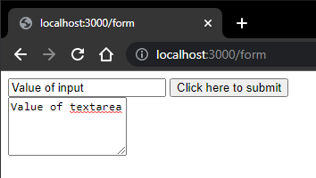

## After submit

